## **Module 1: Lab, Application Debugging Techniques**

Saurabh Kale

IFT 458/554: Middleware Programming & Database Security

Dinesh Sthapit

Aug 26th, 2023

* Debugging using console.log Statements-

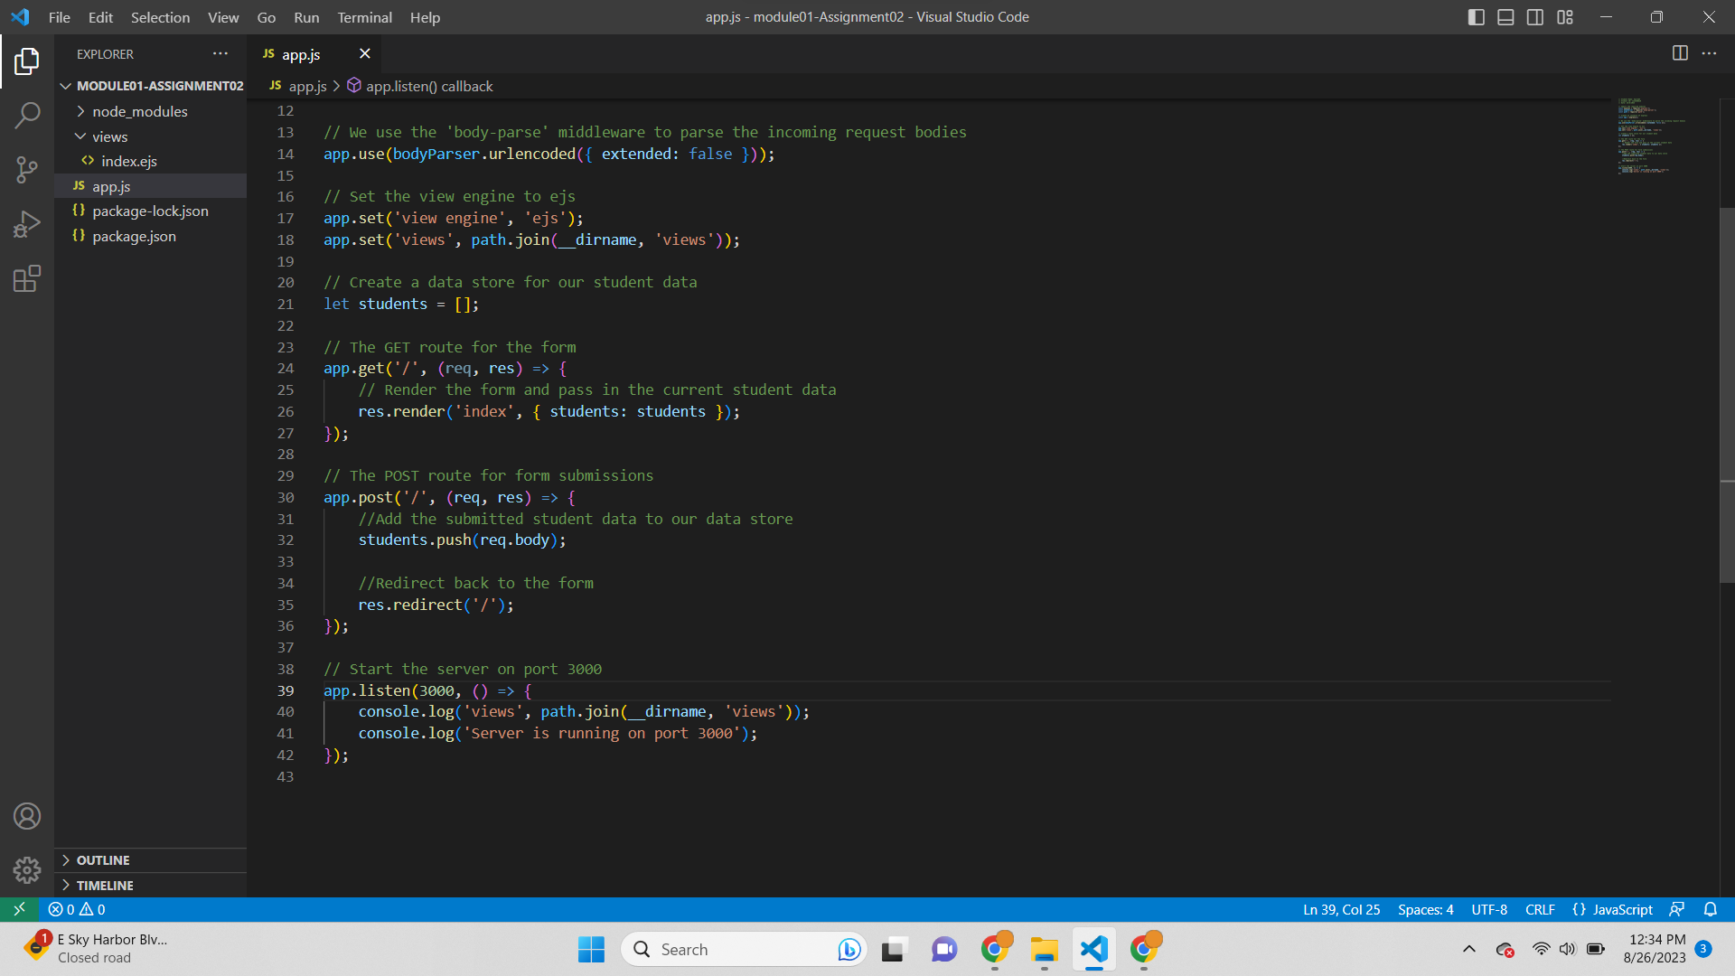

Added console.log in the code to display the path of views folder

Output-

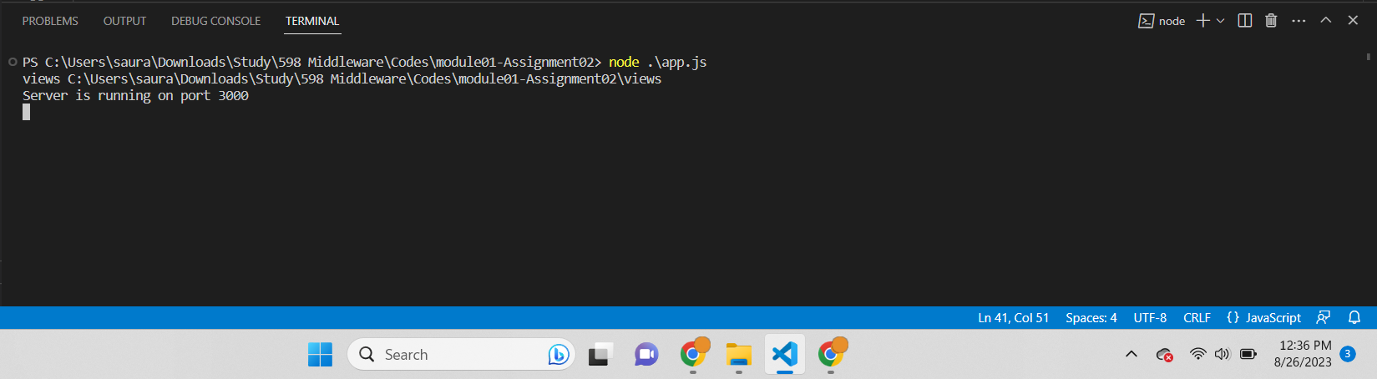

Showing where the views folder is present in the filesystem.

Script-  
PS C:\Users\saura\Downloads\Study\598 Middleware\Codes\module01-Assignment02> node .\app.js

views C:\Users\saura\Downloads\Study\598 Middleware\Codes\module01-Assignment02\views

Server is running on port 3000

* Utilize Node.js Debugger Flag

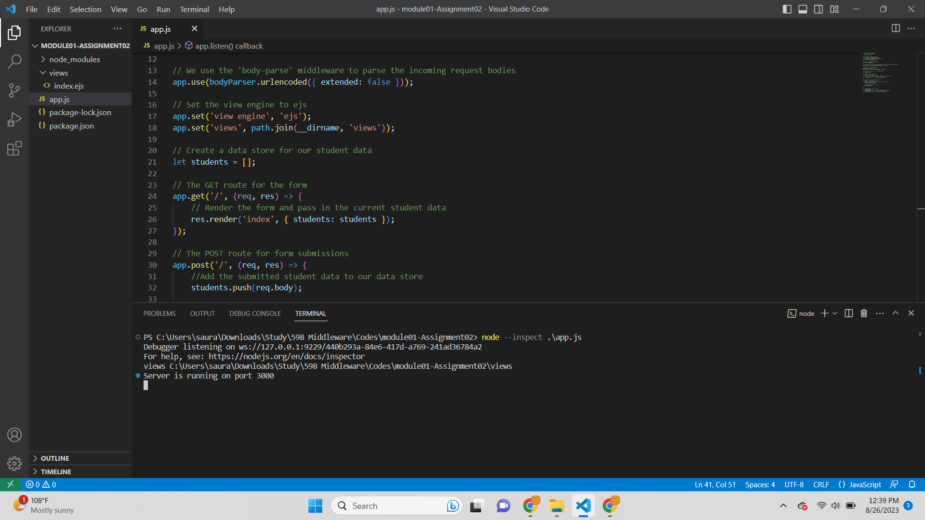

Added debugger flag and the following output is given-  
Script Output-  
PS C:\Users\saura\Downloads\Study\598 Middleware\Codes\module01-Assignment02> node --inspect .\app.js

Debugger listening on ws://127.0.0.1:9229/440b293a-84e6-417d-a769-241ad36784a2

For help, see: https://nodejs.org/en/docs/inspector

views C:\Users\saura\Downloads\Study\598 Middleware\Codes\module01-Assignment02\views

Server is running on port 3000

* Debugger using visual studio-

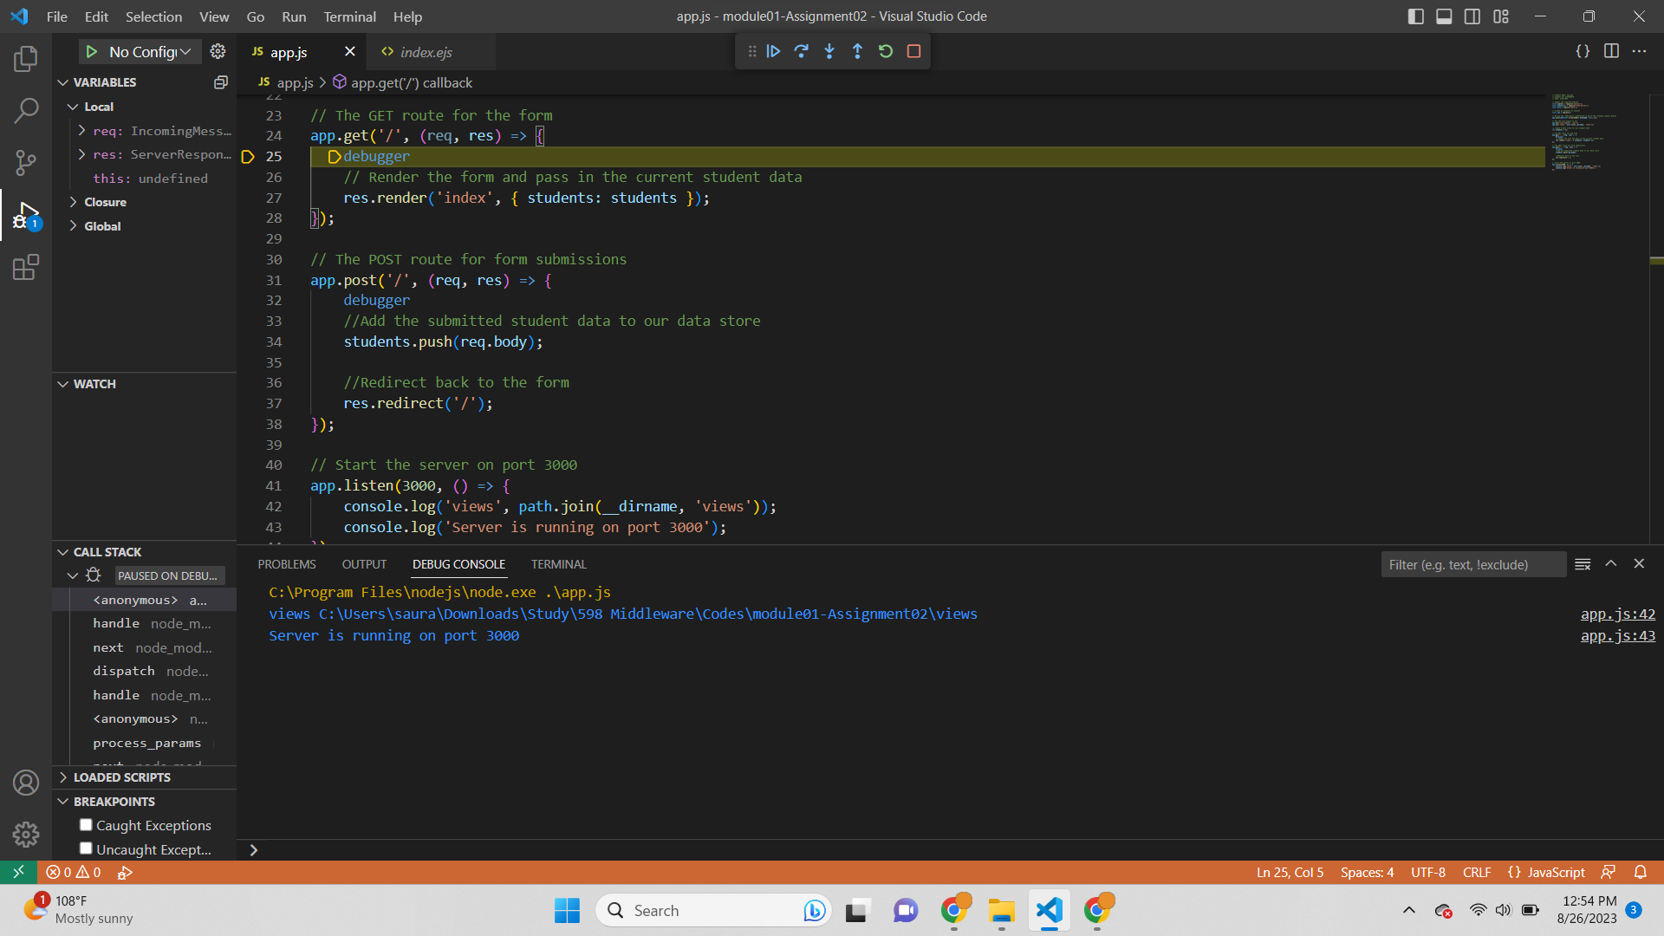

* Debugger stopped in chrome inspect-

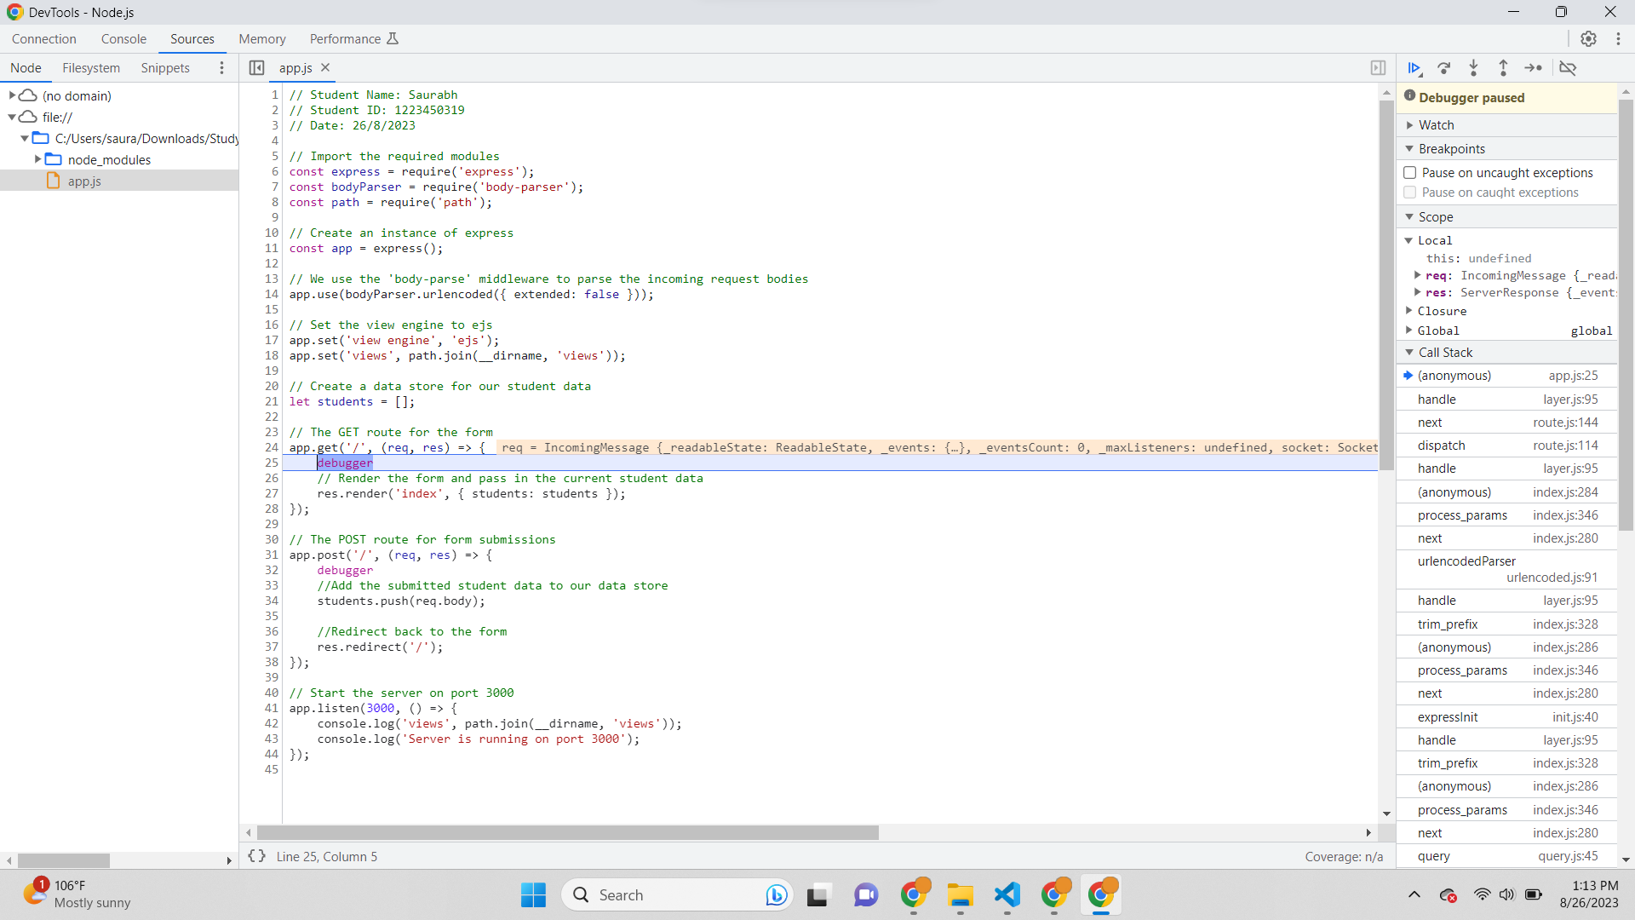

* Debugger with students array on watch-

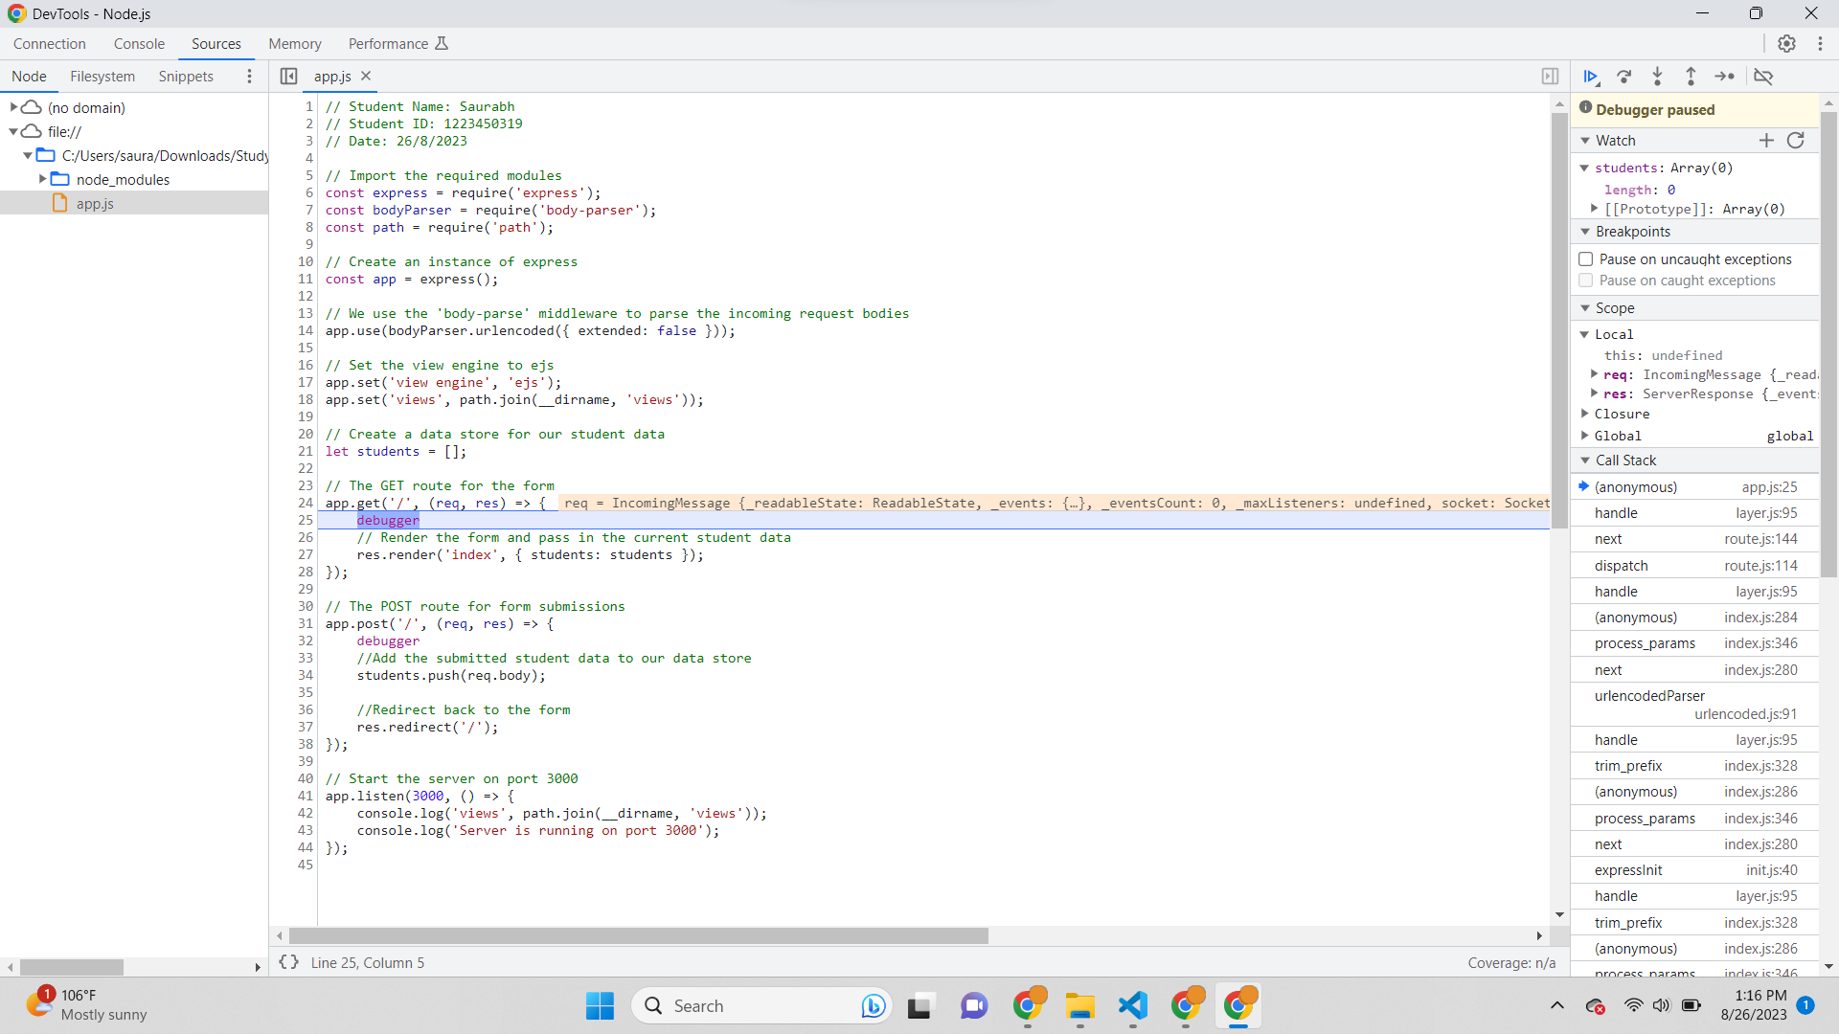

* Debugger with student array having one data in it-

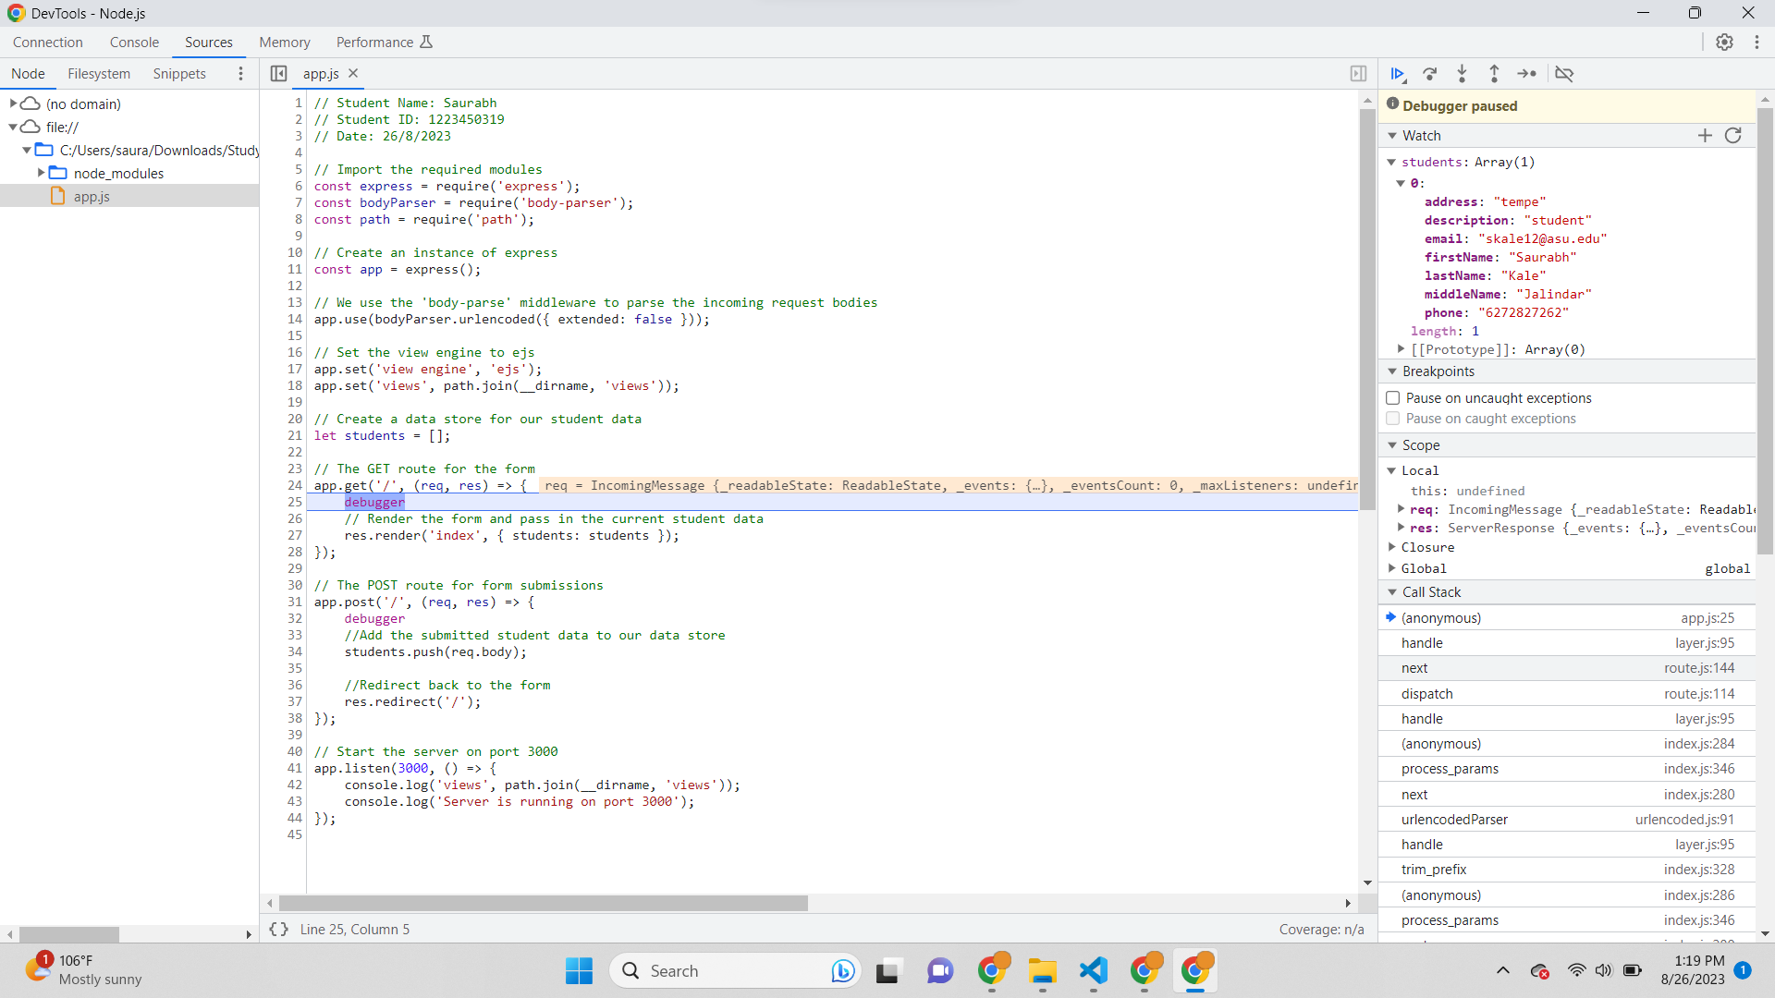

* Visual Studio Javascript Debugger for GET method-

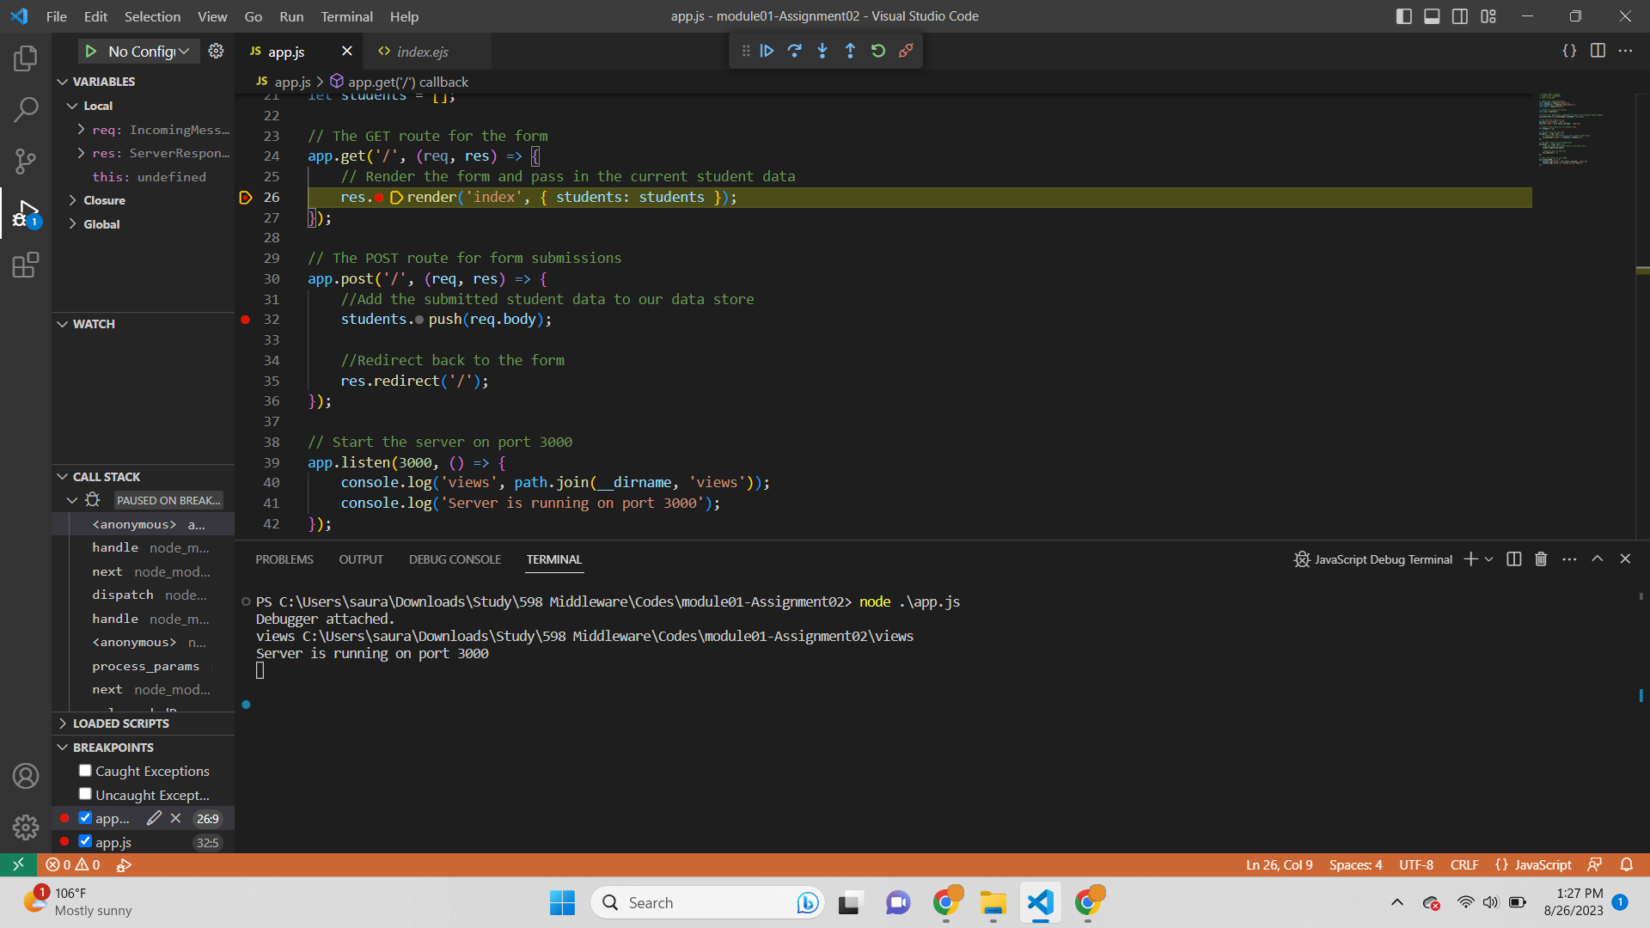

* Visual Studio Code Debugger for POST method-

